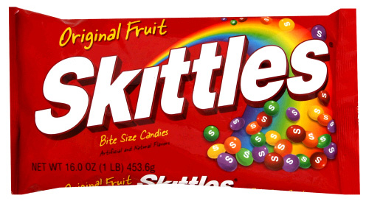
Name ________________________
Date ____________________
SKITTLES DATA

ESTIMATION
Make an estimate, an educated guess, of how many Skittles you think are in your bag. _________

Now make an estimate as to how many of each color you will have in your bag.
Red | Yellow | Green | Purple | Orange

ACTUAL DATA
Record the actual number of each Skittles color in your bag.
Red | Yellow | Green | Purple | Orange

You and your classmates will now share out your total numbers for each color. After that information has been shared and calculated, record the TOTAL number of each Skittles color in your CLASS.
Red | Yellow | Green | Purple | Orange

Remember to be as accurate as possible and double-check your work. This information will be shared with other classes.

Actual Number of Skittles in Your Bag |  |  | Total Number of Skittles in Your Class

©2010-2015 www.theteacherscorner.net

